# Instruction for Predicting the Spreading Powder Process with Different Scraper by Using Yade

## I. Preparation before calculation

1. The spreading powder process is predicted for different scraper situations based on Yade, so you need to install Yade before the calculation (just refer to the official instructions of Yade, the link is: https://yade-dem.org/doc/installation.html);
2. Copy the example folder "differentScraperSpreadPowderSLM_Yade" to any local location.

## II. Calculation process

1. The example folder "differentScraperSpreadPowderSLM_Yade" contains four folders: "A_straightBaffle", "B_baffleWithRoundCorner", "C_noMovingRoller" and "D_movingRoller", which corresponds to the spreading powder process in the case of using a straight baffle, baffle with rounded corners, a non-movable roller, and a movable roller, respectively;
2. Enter the folder "A_straightBaffle", run the command "yade -j32 straightBaffle.py" (here 32 refers to the number of cores used for parallel calculation, which can be modified according to your own computer configuration), click the Start button. At the end of the calculation, it will output the information of the particles in the powder bed area;

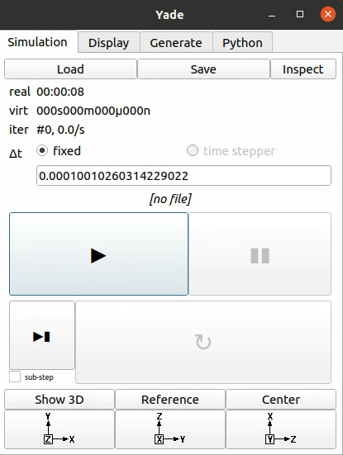

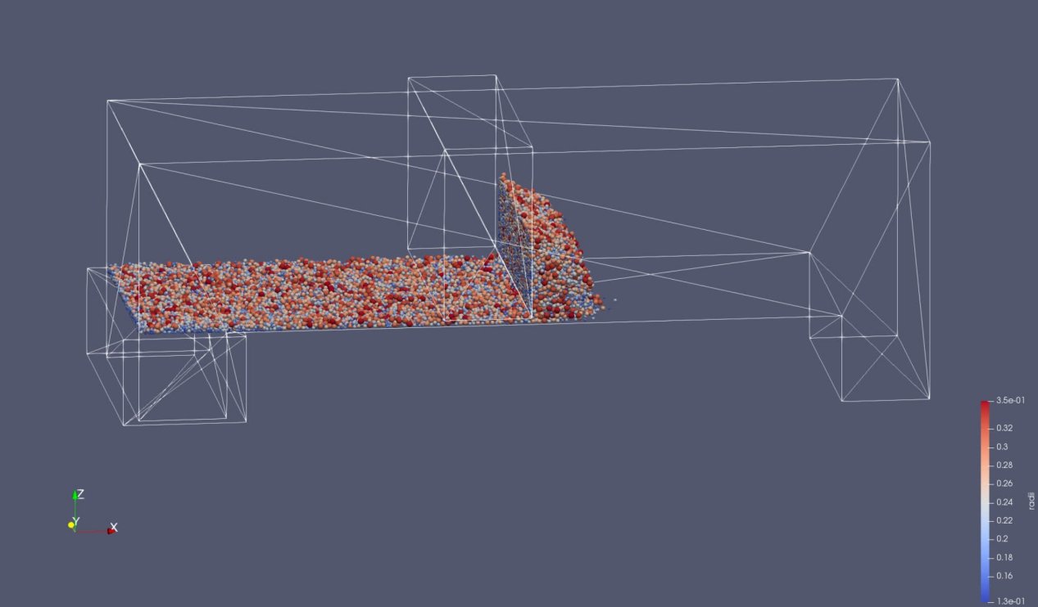

1. Enter the folder "B_baffleWithRoundCorner", run the command "yade -j32 baffleWithRoundCorner.py" (here 32 refers to the number of cores used for parallel calculation), click the Start button. At the end of the calculation, it will output the information of the particles in the powder bed area;

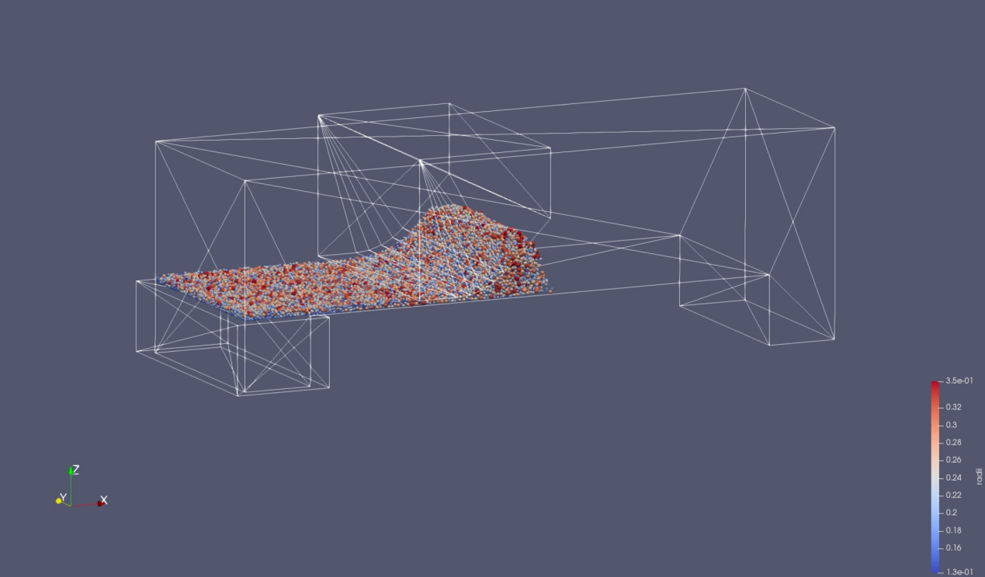

1. Enter the folder "C_noMovingRoller", run the command "yade -j32 noMovingRoller.py" (here 32 refers to the number of cores used for parallel calculation), click the Start button. At the end of the calculation, it will output the information of the particles in the powder bed area;

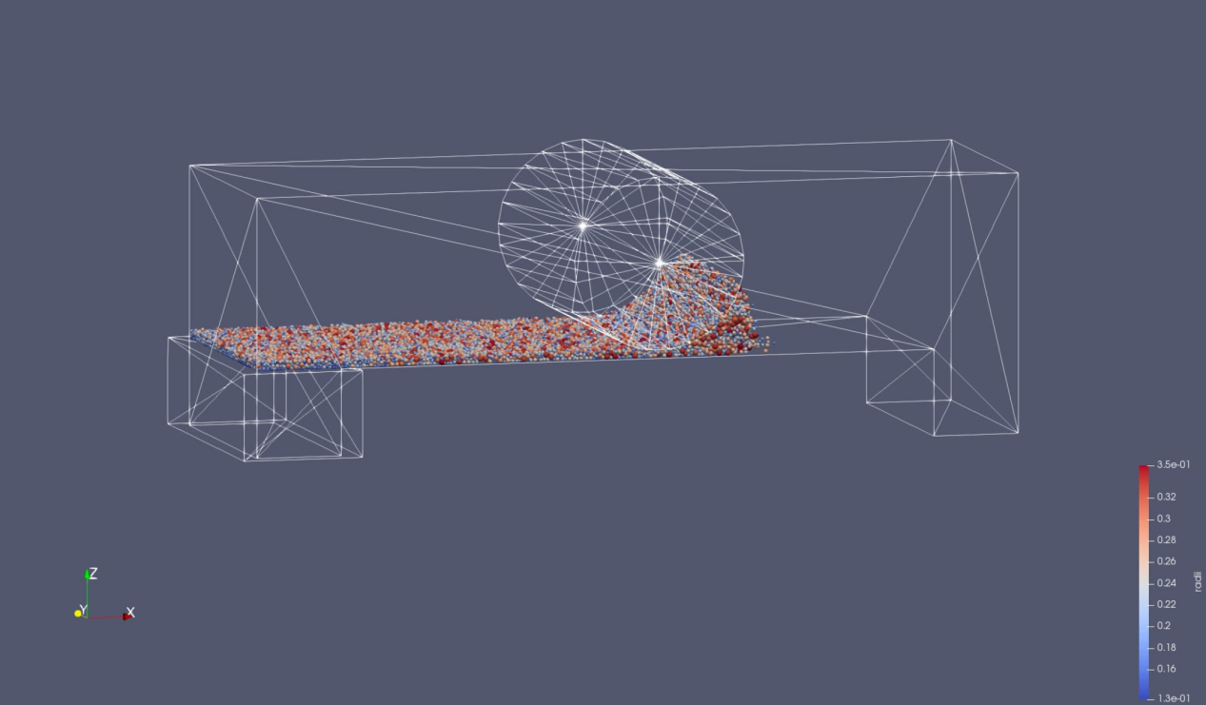

1. Enter the folder "D_movingRoller", run the command "yade -j32 movingRoller.py" (here 32 refers to the number of cores used for parallel calculation), click the Start button. At the end of the calculation, it will output the information of the particles in the powder bed area.

